# 02. Medium

Create a Web page (HTML5 + CSS3) that looks and behaves like the screenshot below:

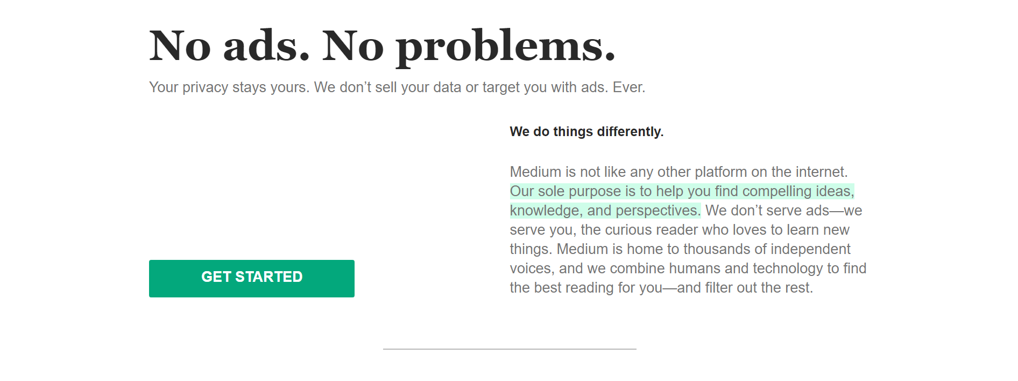

### Output

The output should be valid **HTML5** + **CSS3** + **images** that implement the above web page.

### Constraints

* Use font 'Georgia' for the heading
* Use font 'Helvetica' for the text
* The site should open correctly in the latest version of Chrome